Assignment-based Subjective Questions

Q1. What is the optimal value of alpha for ridge and lasso regression? What will be the changes in the model if you choose double the value of alpha for both ridge and lasso? What will be the most important predictor variables after the change is implemented?
Answer: -
a) What is the optimal value of alpha for ridge and lasso regression?
- The optimal value of alpha for Ridge regression is 500 and Lasso regression is 1000.

b) What will be the changes in the model if you choose double the value of alpha for both ridge and lasso?
- If we double alpha, the models will use even stronger regularization.
- This will shrink the coefficients further making them smaller in magnitude.
- As a result, the models will become simpler and focuses more on the most important features.

c) What will be the most important predictor variables after the change is implemented?
- For Ridge regression, the top 5 important variables (with the largest coefficients) are:
  - “OverallQual”, “GrLivArea”, “Neighborhood_NoRidge”, “1stFlrSF”, and “Neighborhood_NridgHt”.
- For Lasso regression, the top 5 important variables are:
  - “GrLivArea”, “OverallQual”, “Condition2_PosN”, “Neighborhood_NridgHt”, and “GarageCar.
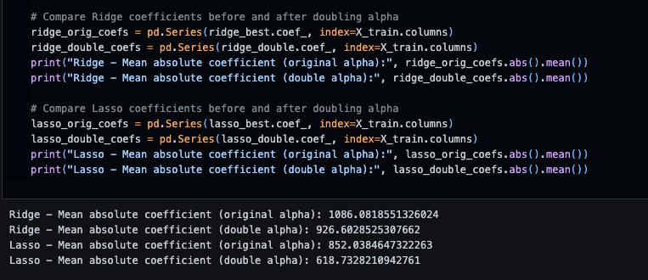

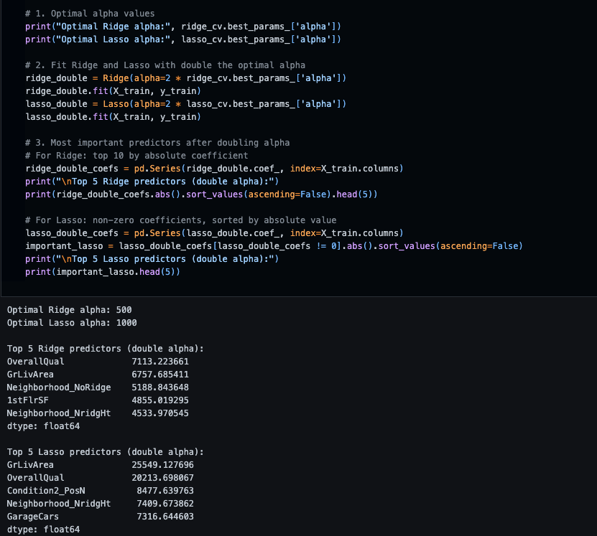
Q2. You have determined the optimal value of lambda for ridge and lasso regression during the assignment. Now, which one will you choose to apply and why?
Answer:-
Both Ridge and Lasso regression are effective regularization techniques, but the choice depends on the problem and data characteristics:
- Ridge regression is preferred when we believe that many features contribute to the target and we want to shrink their coefficients but not eliminate any. It is effective when multicollinearity is present and we want to retain all predictors.
- Lasso regression is preferred when we suspect that only a few features are truly important. Lasso can shrink some coefficients to zero, effectively performing feature selection and resulting in a simpler, more interpretable model.
I would choose Lasso regression for this assignment because my aim is to pinpoint the most important predictors and make the model simpler. Lasso helps achieve this by automatically selecting key features and reducing the coefficients of less relevant ones to zero.

Q3. After building the model, you realised that the five most important predictor variables in the lasso model are not available in the incoming data. You will now have to create another model excluding the five most important predictor variables. Which are the five most important predictor variables now?
Answer:-
After discovering that the five most important predictor variables identified by the Lasso model are not available in the incoming data, I would need to rebuild the model without these variables. To find the next set of important predictors, I would:
- Remove the top five features (with the highest absolute coefficients) from my training data.
- Retrain the Lasso model on the remaining features.
- Check the new model’s coefficients and identify the next five most important predictor variables based on their absolute values.
The five most important predictor variables now would be the ones with the largest absolute coefficients in the updated Lasso model, after excluding the original top five.
The next five most important predictor variables are:
“2ndFlrSF”
“1stFlrSF”
“KitchenQual_Gd”
“KitchenQual_TA”
“BsmtQual_Gd”
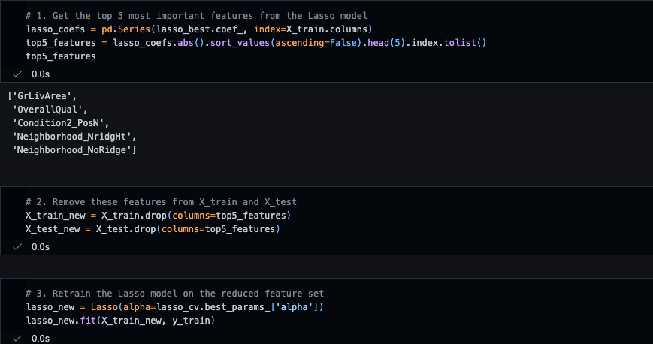
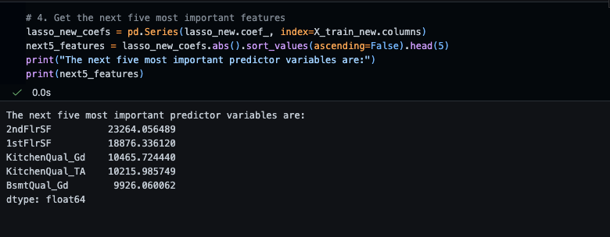

Q4. How can you make sure that a model is robust and generalisable? What are the implications of the same for the accuracy of the model and why?
Answer:-
a) How can you make sure that a model is robust and generalisable?
- I would perform thorough data cleaning and preprocessing, such as handling missing values and encoding categorical variables to ensure the quality of the input data.
- Derived new variables can further enhance model performance and interpretability.
- To make sure that a model is robust and generalisable, I would use techniques such as cross-validation, regularization using Ridge and Lasso regression and by ensuring the model is tested on unseen data (as a separate test set).
- I would also avoid overfitting by not making the model too complex and by using feature selection to keep only the most relevant predictors.
- I would monitor model performance using appropriate metrics such as R² and RMSE on both training and test sets to confirm that the model maintains accuracy and reliability when applied to new data.
b) What are the implications of the same for the accuracy of the model and why?
- The implication of having a robust and generalisable model is that it will perform well not just on the training data, but also on new, unseen data. This means the accuracy measured on the test set will be a reliable indicator of real-world performance.
- If a model is not generalisable, it may show high accuracy on the training data but poor accuracy on new data, which is not useful in practice. Robust models help ensure that predictions remain accurate and consistent when applied to different datasets.

